
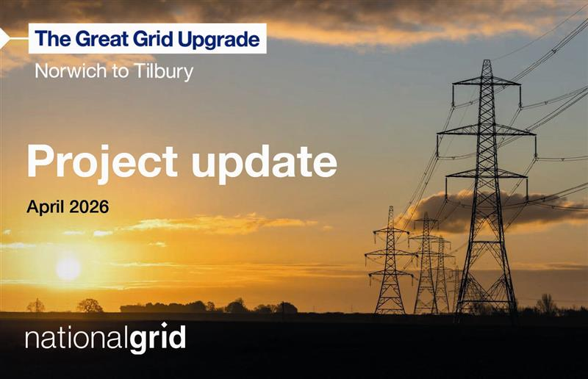

We are proposing to build a new electricity transmission link between Norwich and Tilbury to deliver secure, cleaner, and more affordable energy from where it’s generated to where it’s needed.

Changes to the Norwich to Tilbury project accepted by Examining Authority

We consulted on two small changes to our proposals earlier in the year and submitted a formal request to the Planning Inspectorate on 27 March 2026. After considering our application, the Examining Authority has formally confirmed they have been accepted.

  These are:
  - Change Request 1 (Bulphan) – a change to our Order Limits to allow for third-party access and works for the mitigation of an existing pipeline near Bulphan.
  - Change Request 2 (Little Bromley) – a change to the alignment of the construction access and permanent access routes for a new East Anglia Connection Node (EACN) substation proposed as part of the Norwich to Tilbury project.
  

We’d like to thank everybody who took part and provided feedback.

You can view all the documents for these changes on the Planning Inspectorate’s website here, including a Consultation Report for each change request.
All consultation materials relating to both changes can still be found on our website.

  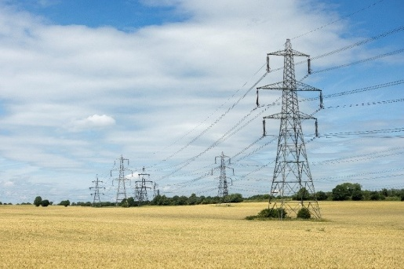
  How to have your say
  Anyone with an interest in these changes can send comments to the Planning Inspectorate during the representation period for these two changes.
  The representation period opened on Thursday 9 April 2026 and closes at 11:59pm on Friday 15 May 2026.

  Any representation relating to the changes must be made on the Planning Inspectorate’s Registration and Relevant Representation Form. To do this, please visit the Planning Inspectorate’s Norwich to Tilbury project page here. Please note that all comments will be published on the Planning Inspectorate’s website.
  Click here to register to have your say with the Planning Inspectorate

If you would prefer a paper copy of the form, you can request one by calling 0303 444 5000 quoting the Norwich to Tilbury Project and the Planning Inspectorate reference (EN020027). Completed forms should be sent to: The Planning Inspectorate, c/o QUADIENT, 69 Buckingham Avenue, Slough, SL1 4PN.

